
American University of Sharjah
Department of Computer Science and Engineering
COE 312
Final Project Report
Class Project Presented by:
Amr Amar (ID: 39614)
Issa Tarick Yezenn Haddad (ID: 47102)
German Shein (ID: 48610)
Spring 2015

Abstract
This project is all about two specific actions; shaking and grabbing. It consists of 2 gloves with 2 pressure sensors and 2 accelerometers attached to each one, along with many other components that will be discussed later on in this report. The main idea of the game is the following; two side numbers will be generated randomly on the screen (left and right hands) the player will have to answer the question of completing the missing sequence by grabbing the right answer (numbers). The screen will show the sequence in the middle, and the player wearing the gloves should grab the number consisting on two digits accordingly. Basically, if the player grabs the left number when the number appears on the screen it is saved as the left digit of the two digit number, then he should grab the right number with the same method mentioned. The accelerometer detects the movement of the player’s hand which is due to a combo move used to grab the numbers. This combo move is achieved after answering a specific number of questions. There are a total of 10 questions to be answered by two players. Player 1 then player 2 plays the game and their score is recorded as the time taken to answer all questions. Timer is placed at the bottom of the gameplay screen. The player with the least time wins the game.

Acknowledgements
We would like to largely express our gratitude for Dr. Imran Zualkernan for helping us all the way during this project and for his advising words that enabled us produce this game. We also would like appreciate Mr. Suresh Raddar for guiding us through the project and helping us detect and correct all our mistakes as we went on.

Table of Contents
I. Introduction 1
Subsection 1 1
Subsection 2 1
Subsection 3 2
II. Design 2
Use Cases 2
Class Diagram 2
Design Patterns 3
Sequence Diagram 5
State Diagram 5
Activity Diagram 6
Package Diagram 7
III. Implementation 8
Hardware
Networking
Software
IV. Results 10
Videos
Screenshots and Photographs
V. List of Components 11
VII. Conclusions 12

List of Figures
Figure ‎III-1. Wavelet detail and approximation coefficients (After reference ‎[6].) 3
Figure ‎III-2. BER as a function of Wavelet denoising using soft thresholding. 4
Figure ‎IV-1. Another inserted figure. 5

List of Tables
Table ‎I-1. Quantities, Symbols, and Units Table (After Reference ‎[2]) 1
Table ‎I-2. Another Quantities, Symbols, and Units Table (After Reference ‎[4]) 1
Table ‎II-1. Yet another Quantities, Symbols, and Units Table. 2

Introduction
The objective of the project is to create a game that utilizes the action of grabbing to trigger a sequence of events. The events that occur when the pressure sensor on the gloves senses a bent are: 1) The numbers on the screen are selected; left glove grabs the left digit and the right glove grabs the right digit 2) The number of questions in the game will decrease by 1 if the numbers grabbed matches the correct answer of the missing number in the sequence (question) generated. The accelerometer acts as a detection of movement used to select numbers. This process is used for the combo move question. The game first starts with a theme music indicating the beginning of the game, then the player chooses to play a new game, view score or exit. There will be two different choices in a new game, one for player 1’s game and the other is for player 2’s game. Next, the player will be directed to the gameplay screen which involves the question in the middle of the screen, 2 fields of numbers generated randomly (0-9) on both sides of the screen, left and right. The number of questions left to answer on the top along with the questions left for the combo move question. Timer and answer of the previous question are on the bottom of the screen. Finally, the target audience of this game is basically 2nd grade children.

Design

The game consists of 2 gloves that the player that desires to play the game must wear. When the game has begun, random question of missing number in the sequence will be generated on the screen and the player must use the sensor on the gloves to grab both the left digit and the right digit. If he grabs in the correct digits the game will view his answer, decrement the questions by 1 and his combo-move question gets decremented to indicate how many questions are left until the player gets the combo. If the player grabs the wrong number, the game will not show his answer and the timer will keep going resulting in a less chance of winning. The point of the game is to have the least time taken to answer by the players and then indicate the winner based on that.

Use Cases

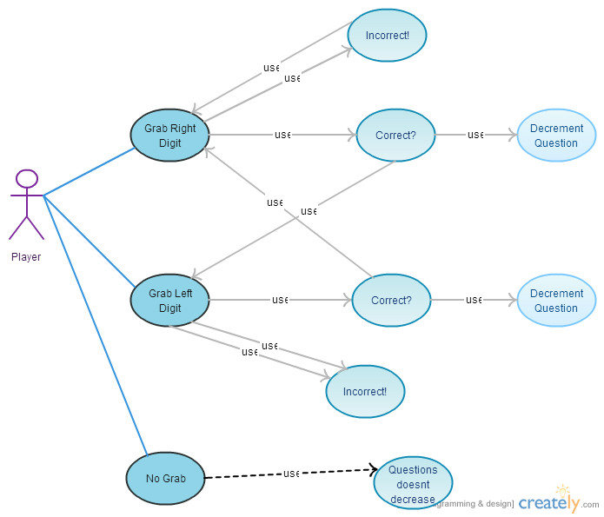

Class Diagram
The Game accesses the Problem class to retrieve the generated questions and show it to the main screen along with the timer (score).
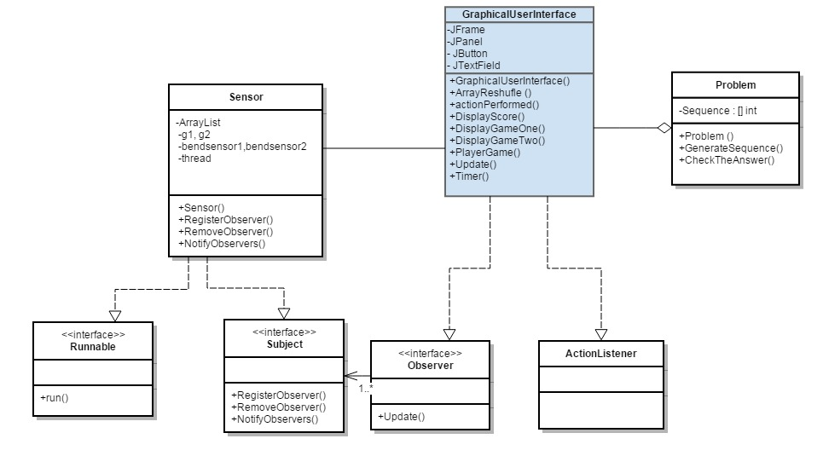

Design Patterns
We used observer Pattern to keep Track of User Data and Sensor Data.
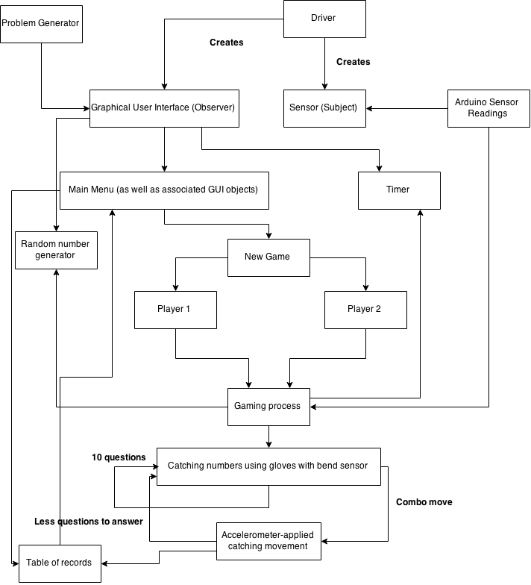

Sequence Diagram
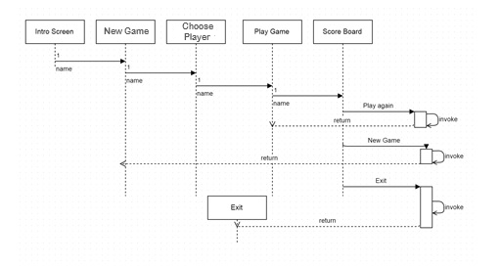

State Diagram

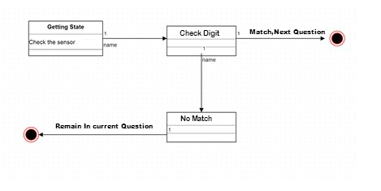

Activity Diagram
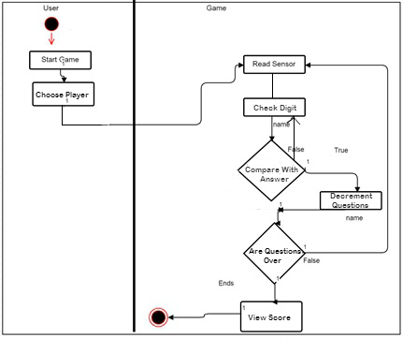

Package Diagram
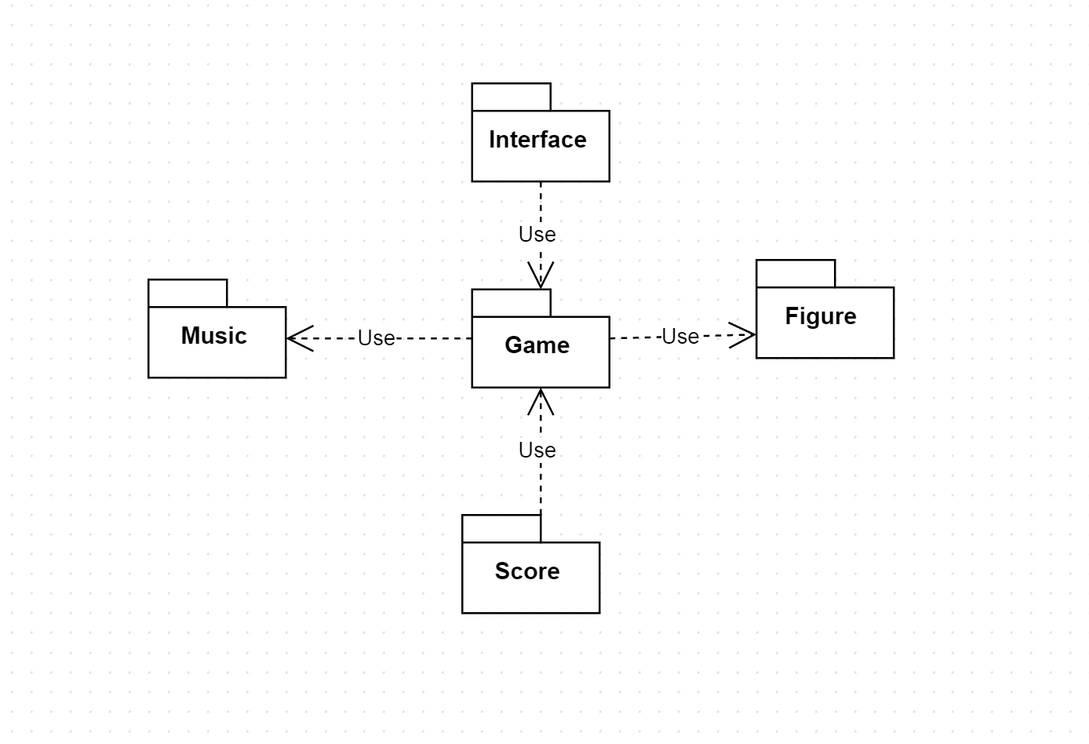

Implementation

Hardware
The Project contains four major components. First, it has the accelerometer which is basically our ‘Combo’ sensing (grabbing) component. Secondly, there is the Lilypad microcontroller that is connected to the pressure sensors; the microcontroller translates the values from the accelerometer into: 0 for applied pressure and 1 for no pressure. These values are determined by specified ranges in the code we developed. Thirdly, there is the XBee Module mounted on Lilypad XBee Breakout Board that is connected directly to the microcontroller, and its pair is connected to the computer that the game plays on. The last component is the DC power source (batteries) that powers up the whole system. We put each item on a T-Shaped wooden board and then we soldiered the wires so they stay attached permanently.

Networking
A Zigbee network was setup to communicate between the two end points which are the microcontroller and the computer.
The microcontroller and the accelerometer are connected through wires like shown in the figure 1 bellow. The microcontroller is also connected to the XBee Module mounted on XBee Explorer USB like shown in figure 2 bellow. And they are all connected to the battery’s positive and negative terminals.
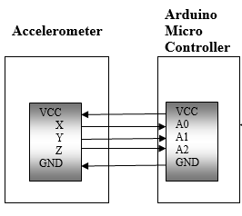
Figure 1
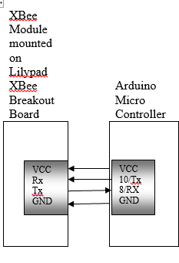
Figure 2

Software
- PC
A Java code written and compiled on Eclipse is used on the PC. It includes all the design patterns and the main methods that start the game. The following classes, functions, and states implement our game.
- Game
- StartGame
- View Score
- ExitGame
- GameOpen
- Choose Player
- ReturnToPreviousState
- GamePlay
- GrabNumbers
- SequenceGenerated
- YourAnswer
- Timer
- TillComboQuestionsLeft
- Scores
- ArrangeScores
- DeclareWinner
- ExitGame
- Communication
- SerialPortStreams
- Observer
- Subject
- Lilypad Microcontroller
Arduino code is uploaded to the microcontroller; we modified the existing examples to comply with our project. The microcontroller continuously sends data from the pressure sensor and accelerometer. It writes them to the serial port. The pressure sensors’ data is being sent as digital data and a threshold was determined to grab a number. We specified the ranges for the left and right accelerometers by checking the values that the microcontroller reads when the accelerometer moves right or left and then grab the number.
- Codes:
- Arduino:

#include <SoftwareSerial.h>

SoftwareSerial myserial (10, 11);

void setup ()
{
Serial.begin (9600);
myserial.begin (9600);
}

void loop ()
{
int bendsensor1, bendsensor2, x1, y1, x2, y2;
double gx1, gy1, gx2, gy2;
double g1, g2;
x1 = analogRead (A0);
y1 = analogRead (A1);
bendsensor1 = analogRead (A2);
x2 = analogRead (A3);
y2 = analogRead (A4);
bendsensor2 = analogRead (A5);
gx1 = 2/((615 - 394) * 1.0) * (x1 - 394) - 1;
gy1 = 2/((625 - 386) * 1.0) * (y1 - 386) - 1;
gx2 = 2/((615 - 394) * 1.0) * (x2 - 394) - 1;
gy2 = 2/((625 - 386) * 1.0) * (y2 - 386) - 1;
g1 = sqrt (gx1 * gx1 + gy1 * gy1);
g2 = sqrt (gx2 * gx2 + gy2 * gy2);
Serial.print (bendsensor1);
Serial.print (" ");
Serial.print (bendsensor2);
Serial.print (" ");
Serial.print (g1);
Serial.print (" ");
Serial.print (g2);
Serial.println ();
myserial.print (bendsensor1);
myserial.print (" ");
myserial.print (bendsensor2);
myserial.print (" ");
myserial.print (g1);
myserial.print (" ");
myserial.print (g2);
myserial.println ();
delay (1000);
}

- Java:
public class Driver
{
public static void main (String [] args) throws SerialPortException
{
Sensor sensor = new Sensor ();
GraphicalUserInterface gui = new GraphicalUserInterface (sensor);
}
}

import java.awt.*;
import sun.audio.*;
import javax.sound.sampled.*;
import java.awt.event.*;
import java.io.FileInputStream;
import java.io.FileNotFoundException;
import java.io.IOException;
import java.io.InputStream;
import java.util.Random;
import javax.swing.*;

public class GraphicalUserInterface implements ActionListener, Observer
{
private static final String ContinuousAudioDataStream = null;
JFrame f1;
JFrame f2;
JFrame f3;
JFrame f4;
JFrame f5;
JButton b1,b2,b3,b11,b21,b31,b32,b33,b51;
JPanel p11,p21,p22,p23,p3,p51,p52,p53;
JTextField t11,t12,t201,t202,t203,t204,t205,t206,t207,t208,t209,t210,t211,t212,t213,t214,t215,t216,t217,bonus1;
JTextField t501,t502,t503,t504,t505,t506,t507,t508,t509,t510,t511,t512,t513,t514,t515,t516,t517,bonus2;
JLabel l11,l12,l13,l14,l15,l16,l201,l202,l203,l204,l205,l206,l207,l208,l209,l210,l211,l212,l213,l214,l215,l216,l217,l218,l219,l220,l221,l222,l223,l224,l225,l226,l227,l230,l231,l232,l233,l234,l31;
JLabel l501,l502,l503,l504,l505,l506,l507,l508,l509,l510,l511,l512,l513,l514,l515,l516,l517,l518,l519,l520,l521,l522,l523,l524,l525,l526,l527,l530,l531,l532,l533,l534;
Container c;
GridLayout layout1,layout2,layout3,layout4,layout5;
Font font = new Font("Comic Sans MS", Font.BOLD, 18);
Font font2 = new Font("baghdad", Font.BOLD ,14);
Font font3 = new Font("baghdad", Font.BOLD, 16);
Integer numberofquestions;
Problem problem;
double g1, g2;
int [] numbersequence, numberstocatch1, numberstocatch2;
int answer, bs1, bs2, number1, number2, catch1, catch2, time, timer1, timer2, correctanswersinarow1, correctanswersinarow2, numberofactivationsofrecordtable;
Subject sensor;

public GraphicalUserInterface (Subject s)
{
playonce("src/Mario_Kart_Race_Start_-_Gaming_Sound_Effect_HD_.wav");
numberofactivationsofrecordtable = 0;
correctanswersinarow1 = 0;
correctanswersinarow2 = 0;
timer1 = timer2 = 0;
int index;
time = 2500;
sensor = s;
sensor.RegisterObserver (this);
layout1 = new GridLayout(3,1);
f1 = new JFrame("Java Frame");
f1.setLayout(layout1);
b1 = new JButton("New Game");
f1.add(b1 , BorderLayout.NORTH);
b1.addActionListener(this);
b2 = new JButton("Score");
f1.add(b2, BorderLayout.CENTER);
b2.addActionListener(this);
b3 = new JButton("Exit");
f1.add(b3 , BorderLayout.SOUTH);
b3.addActionListener(this);
f1.setDefaultCloseOperation(JFrame.EXIT_ON_CLOSE);
f1.setSize(400,300);
f1.setVisible(true);
numberofquestions = 10;
numberstocatch1 = new int [10];
numberstocatch2 = new int [10];
for (index = 0; index < 10; index = index + 1)
{
numberstocatch1 [index] = index;
}
for (index = 9; index >= 0; index = index - 1)
{
numberstocatch2 [index] = 9 - index;
}
t203= new JTextField();
t212= new JTextField();
t215= new JTextField();
t503= new JTextField();
t512= new JTextField();
t515= new JTextField();
Runnable randomnumbers = new Runnable ()
{
int index = 0;
public void run ()
{
while (true)
{
number1 = numberstocatch1 [index];
number2 = numberstocatch2 [index];
t203.setText (((Integer) number1).toString ());
t215.setText (((Integer) number2).toString ());
t503.setText (((Integer) number1).toString ());
t515.setText (((Integer) number2).toString ());
try
{
Thread.sleep (time);
}
catch (InterruptedException ie)
{
ie.printStackTrace();
}
index = index + 1;
if (index > 9)
{
index = 0;
ArrayReshufle (numberstocatch1);
ArrayReshufle (numberstocatch2);
}
}
}
};
Thread thread1 = new Thread (randomnumbers);
thread1.start ();
Runnable runningtimer = new Runnable ()
{
public void run ()
{
while (true)
{
t212.setText (((Integer) timer1).toString () + " s");
t512.setText (((Integer) timer2).toString () + " s");
timer1 = timer1 + 1;
timer2 = timer2 + 1;
try
{
Thread.sleep (1000);
}
catch (InterruptedException ie)
{
ie.printStackTrace ();
}

}
}
};
Thread thread2 = new Thread (runningtimer);
thread2.start ();

}

public void ArrayReshufle (int [] array)
{
int index, temp, tempindex;
Random random = new Random ();
for (index = array.length - 1; index > 0; index = index - 1)
{
tempindex = random.nextInt (index + 1);
temp = array [tempindex];
array [tempindex] = array [index];
array [index] = temp;
}
}

public void actionPerformed(ActionEvent ae)
{

if (ae.getSource()==b1)
{
PlayerGame();
f1.setVisible(false);
}
if (ae.getSource()==b2)
{
DisplayScore();
f1.setVisible(false);
}
if (ae.getSource()==b3)
{
playonce("src/Gun_Load_-_Sound_Effect.wav");
System.exit(0);
}
if (ae.getSource()==b11)
{
f1.setVisible (true);
f2.setVisible (false);
}
if (ae.getSource()==b21)
{
numberofquestions = 10;
correctanswersinarow1 = 0;
problem = new Problem ();
numbersequence = problem.GenerateSequence ();
f4.setVisible(true);
f3.setVisible(false);
}
if (ae.getSource()==b31)
{
DisplayGameOne();
f4.setVisible(false);
}
if (ae.getSource()==b51)
{
numberofquestions = 10;
correctanswersinarow2 = 0;
problem = new Problem ();
numbersequence = problem.GenerateSequence ();
f4.setVisible(true);
f5.setVisible(false);
}
if (ae.getSource()==b32)
{
DisplayGameTwo();
f4.setVisible(false);
}
if (ae.getSource()==b33)
{
f4.setVisible(false);
f1.setVisible(true);
}
}
public void DisplayScore()
{
playonce("src/Gun_Load_-_Sound_Effect.wav");
layout2 = new GridLayout();
f2 =new JFrame("Score Board");
f2.setLayout(layout2);
p11 = new JPanel();
p11.setLayout(new GridLayout(3,3));
l11 = new JLabel("Player 1",SwingConstants.CENTER);
l12 = new JLabel("Player 2",SwingConstants.CENTER);
l13 = new JLabel("Time Spent:",SwingConstants.CENTER);
l14 = new JLabel("Result:",SwingConstants.CENTER);
l15 = new JLabel("WINNER!",SwingConstants.CENTER);
l16 = new JLabel("LOSER!",SwingConstants.CENTER);
b11 = new JButton("back");
b11.addActionListener(this);
t11 = new JTextField("50");
t12 = new JTextField("20");
p11.add(b11);
p11.add(l11);
p11.add(l12);
p11.add(l13);
p11.add(t11);
p11.add(t12);
p11.add(l14);
if((Integer.parseInt(t11.getText()))<(Integer.parseInt(t12.getText())))
{
p11.add(l15);
p11.add(l16);
}
else
{
p11.add(l16);
p11.add(l15);
}
f2.add(p11);
f2.setDefaultCloseOperation(JFrame.EXIT_ON_CLOSE);
f2.setSize(300,300);
f2.setVisible(true);
}

public void DisplayGameOne()
{
DisplayScore ();
f2.setVisible (false);
playonce("src/Super_Mario_Bros.wav");
timer1 = 0;
layout3 = new GridLayout();
layout3 = new GridLayout();
f3 = new JFrame("Game board");
f3.setLayout(layout3);
p21= new JPanel();
p22= new JPanel();
p23= new JPanel();
p21.setLayout(new GridLayout(5,2));
p22.setLayout(new GridLayout(5,5));
p23.setLayout(new GridLayout(5,2));
l201=new JLabel("----------------->", SwingConstants.RIGHT);
l202=new JLabel("<-----------------",SwingConstants.LEFT);
l203=new JLabel("PLAYER 1", SwingConstants.CENTER);
l203.setFont(font);
l204=new JLabel("Q no.",SwingConstants.RIGHT);
l205=new JLabel("TIME:",SwingConstants.RIGHT);
l206=new JLabel("");
l207=new JLabel("First Digit ->",SwingConstants.RIGHT);
l208=new JLabel("");
l209=new JLabel("");
l210=new JLabel("till BONUS",SwingConstants.RIGHT);
l211=new JLabel("");
l212=new JLabel("");
l213=new JLabel("");
l214=new JLabel("");
l215=new JLabel("");
l216=new JLabel("");
l217=new JLabel("");
l218=new JLabel("");
l219=new JLabel("");
l220=new JLabel("");
l221=new JLabel("");
l222=new JLabel("");
l223=new JLabel("");
l224=new JLabel("");
l225=new JLabel("<- Second Digit",SwingConstants.LEFT);
l226=new JLabel("");
l227=new JLabel("Your Answer:",SwingConstants.RIGHT);
l230= new JLabel("");
t202= new JTextField();
t202.setFont(font3);
t203= new JTextField();
t203.setFont(font3);
l232= new JLabel("");
l234= new JLabel("");
t206= new JTextField();
t207= new JTextField();
t207.setFont(font2);
t208= new JTextField();
t208.setFont(font2);
t209= new JTextField();
t209.setFont(font2);
t210= new JTextField();
t210.setFont(font2);
t211= new JTextField();
t211.setFont(font2);
t212= new JTextField();
l231= new JLabel("");
t214= new JTextField();
t214.setFont(font3);
t215= new JTextField();
t215.setFont(font3);
l233= new JLabel("");
t217= new JTextField();
t217.setFont(font);
bonus1 = new JTextField();
b21=new JButton("Back");
b21.addActionListener(this);
p21.add(b21);
p21.add(l230);
p21.add(l207);
p21.add(t202);
p21.add(l201);
p21.add(t203);
p21.add(l208);
p21.add(l232);
p21.add(l209);
p21.add(l234);
p22.add(l204);
p22.add(t206);
p22.add(l210);
p22.add(bonus1);
p22.add(l206);
p22.add(l212);
p22.add(l213);
p22.add(l203);
p22.add(l214);
p22.add(l215);
p22.add(t207);
p22.add(t208);
p22.add(t209);
p22.add(t210);
p22.add(t211);
p22.add(l216);
p22.add(l217);
p22.add(l218);
p22.add(l219);
p22.add(l220);
p22.add(l221);
p22.add(l205);
p22.add(t212);
p22.add(l222);
p22.add(l223);
p23.add(l231);
p23.add(l224);
p23.add(t214);
p23.add(l225);
p23.add(t215);
p23.add(l202);
p23.add(l233);
p23.add(l226);
p23.add(l227);
p23.add(t217);
f3.add(p21);
f3.add(p22);
f3.add(p23);
t202.setEditable (false);
t203.setEditable (false);
t206.setEditable (false);
t207.setEditable (false);
t208.setEditable (false);
t209.setEditable (false);
t210.setEditable (false);
t211.setEditable (false);
t212.setEditable (false);
t214.setEditable (false);
t215.setEditable (false);
t217.setEditable (false);
bonus1.setEditable (false);
t206.setText (numberofquestions.toString ());
problem = new Problem ();
numbersequence = problem.GenerateSequence ();
t207.setText (((Integer) numbersequence [0]).toString ());
t208.setText (((Integer) numbersequence [1]).toString ());
t209.setText (((Integer) numbersequence [2]).toString ());
t210.setText (((Integer) numbersequence [3]).toString ());
t211.setText ("??");
bonus1.setText (((Integer) correctanswersinarow1).toString ());
f3.setDefaultCloseOperation(JFrame.EXIT_ON_CLOSE);
f3.setSize(1500,500);
f3.setVisible(true);
}

void DisplayGameTwo()
{
DisplayScore ();
f2.setVisible (false);
playonce("src/Super_Mario_Bros.wav");
timer2 = 0;
layout5 = new GridLayout();
f5 = new JFrame("Game board");
f5.setLayout(layout5);
p51= new JPanel();
p52= new JPanel();
p53= new JPanel();
p51.setLayout(new GridLayout(5,2));
p52.setLayout(new GridLayout(5,5));
p53.setLayout(new GridLayout(5,2));
l501=new JLabel("----------------->", SwingConstants.RIGHT);
l502=new JLabel("<-----------------",SwingConstants.LEFT);
l503=new JLabel("PLAYER 2", SwingConstants.CENTER);
l503.setFont(font);
l504=new JLabel("Q no.",SwingConstants.RIGHT);
l505=new JLabel("TIME:",SwingConstants.RIGHT);
l506=new JLabel("");
l507=new JLabel("First Digit ->",SwingConstants.RIGHT);
l508=new JLabel("");
l509=new JLabel("");
l510=new JLabel("till BONUS",SwingConstants.RIGHT);
l511=new JLabel("");
l512=new JLabel("");
l513=new JLabel("");
l514=new JLabel("");
l515=new JLabel("");
l516=new JLabel("");
l517=new JLabel("");
l518=new JLabel("");
l519=new JLabel("");
l520=new JLabel("");
l521=new JLabel("");
l522=new JLabel("");
l523=new JLabel("");
l524=new JLabel("");
l525=new JLabel("<- Second Digit",SwingConstants.LEFT);
l526=new JLabel("");
l527=new JLabel("Your Answer:",SwingConstants.RIGHT);
l530= new JLabel("");
t502= new JTextField();
t502.setFont(font3);
t503= new JTextField();
t503.setFont(font3);
l532= new JLabel("");
l534= new JLabel("");
t506= new JTextField();
t507= new JTextField();
t507.setFont(font2);
t508= new JTextField();
t508.setFont(font2);
t509= new JTextField();
t509.setFont(font2);
t510= new JTextField();
t510.setFont(font2);
t511= new JTextField();
t511.setFont(font2);
t512= new JTextField();
l531= new JLabel("");
t514= new JTextField();
t514.setFont(font3);
t515= new JTextField();
t515.setFont(font3);
l533= new JLabel("");
t517= new JTextField();
t517.setFont(font);
bonus2 = new JTextField();
b51=new JButton("Back");
b51.addActionListener(this);
p51.add(b51);
p51.add(l530);
p51.add(l507);
p51.add(t502);
p51.add(l501);
p51.add(t503);
p51.add(l508);
p51.add(l532);
p51.add(l509);
p51.add(l534);
p52.add(l504);
p52.add(t506);
p52.add(l510);
p52.add(bonus2);
p52.add(l506);
p52.add(l512);
p52.add(l513);
p52.add(l503);
p52.add(l514);
p52.add(l515);
p52.add(t507);
p52.add(t508);
p52.add(t509);
p52.add(t510);
p52.add(t511);
p52.add(l516);
p52.add(l517);
p52.add(l518);
p52.add(l519);
p52.add(l520);
p52.add(l521);
p52.add(l505);
p52.add(t512);
p52.add(l522);
p52.add(l523);
p53.add(l531);
p53.add(l524);
p53.add(t514);
p53.add(l525);
p53.add(t515);
p53.add(l502);
p53.add(l533);
p53.add(l526);
p53.add(l527);
p53.add(t517);
f5.add(p51);
f5.add(p52);
f5.add(p53);
t502.setEditable (false);
t503.setEditable (false);
t506.setEditable (false);
t507.setEditable (false);
t508.setEditable (false);
t509.setEditable (false);
t510.setEditable (false);
t511.setEditable (false);
t512.setEditable (false);
t514.setEditable (false);
t515.setEditable (false);
t517.setEditable (false);
bonus2.setEditable (false);
t506.setText (numberofquestions.toString ());
problem = new Problem ();
numbersequence = problem.GenerateSequence ();
t507.setText (((Integer) numbersequence [0]).toString ());
t508.setText (((Integer) numbersequence [1]).toString ());
t509.setText (((Integer) numbersequence [2]).toString ());
t510.setText (((Integer) numbersequence [3]).toString ());
t511.setText ("??");
bonus2.setText (((Integer) correctanswersinarow2).toString ());
f5.setDefaultCloseOperation(JFrame.EXIT_ON_CLOSE);
f5.setSize(1500,500);
f5.setVisible(true);
}

void PlayerGame()
{
playonce("src/Gun_Load_-_Sound_Effect.wav");
layout4 =new GridLayout();
f4 = new JFrame("Choose Player");
f4.setLayout(layout4);
p3 = new JPanel();
p3.setLayout(new GridLayout(1,4));
b31 = new JButton("Player 1");
b31.addActionListener(this);
b32 = new JButton("Player 2");
b32.addActionListener(this);
b33 = new JButton("Back");
b33.addActionListener(this);
l31 = new JLabel("Vs",SwingConstants.CENTER);
p3.add(b33);
p3.add(b31);
p3.add(l31);
p3.add(b32);
f4.add(p3);
f4.setDefaultCloseOperation(JFrame.EXIT_ON_CLOSE);
f4.setSize(300,100);
f4.setVisible(true);
}
void playonce(String filename)
{
InputStream in = null;
try {
in = new FileInputStream(filename);
} catch (FileNotFoundException e) {
// TODO Auto-generated catch block
e.printStackTrace();
}
AudioStream as = null;
try {
as = new AudioStream(in);
} catch (IOException e) {
// TODO Auto-generated catch block
e.printStackTrace();
}
AudioPlayer.player.start(as);
}
void playloop(String filename)
{
InputStream in = null;
try {
in = new FileInputStream(filename);
} catch (FileNotFoundException e1) {
// TODO Auto-generated catch block
e1.printStackTrace();
}
AudioStream as = null;
try {
as = new AudioStream(in);
} catch (IOException e) {
// TODO Auto-generated catch block
e.printStackTrace();
}
AudioData data = null;
try {
data = as.getData();
} catch (IOException e) {
// TODO Auto-generated catch block
e.printStackTrace();
}
ContinuousAudioDataStream cas = new ContinuousAudioDataStream (data);
AudioPlayer.player.start(cas);
}
public void Update (int bs1, int bs2, double g1, double g2)
{
this.bs1 = bs1;
this.bs2 = bs2;
this.g1 = g1;
this.g2 = g2;
int temp = 0;
temp = numberofquestions % 3;
bonus1.setText (((Integer) temp).toString ());
if (numberofquestions <= 0)
{
f5.dispose ();
t12.setText (((Integer) timer2).toString ());
if (numberofactivationsofrecordtable > 0)
{
f2.setVisible (true);
numberofactivationsofrecordtable = numberofactivationsofrecordtable + 1;
}
}
if (numberofquestions % 3 == 0)
{
if (g1 > 1.5)
{
catch1 = number1;
t202.setText (((Integer) catch1).toString ());
f3.repaint ();
}
else if (g2 > 1.5)
{
catch2 = number2;
t214.setText (((Integer) catch2).toString ());
f3.repaint ();
}
correctanswersinarow1 = 0;
if (problem.CheckTheAnswer (answer))
{
numberofquestions = numberofquestions - 3;
}
}
else
{
if (bs1 < 500)
{
catch1 = number1;
t202.setText (((Integer) catch1).toString ());
f3.repaint ();
}
else if (bs2 < 650)
{
catch2 = number2;
t214.setText (((Integer) catch2).toString ());
f3.repaint ();
}
if (problem.CheckTheAnswer (answer))
{
numberofquestions = numberofquestions - 1;
}
}
if (numberofquestions <= 0)
{
f3.dispose ();
t11.setText (((Integer) timer1).toString ());
if (numberofactivationsofrecordtable > 0)
{
f2.setVisible (true);
numberofactivationsofrecordtable = numberofactivationsofrecordtable + 1;
}
}
answer = 10 * catch1 + catch2;
f3.repaint ();
if (problem.CheckTheAnswer (answer))
{
numberofquestions = numberofquestions - 1;
t206.setText (numberofquestions.toString ());
t217.setText (((Integer) answer).toString ());
time = time - 125;
t206.setText (numberofquestions.toString ());
numbersequence = problem.GenerateSequence ();
t207.setText (((Integer) numbersequence [0]).toString ());
t208.setText (((Integer) numbersequence [1]).toString ());
t209.setText (((Integer) numbersequence [2]).toString ());
t210.setText (((Integer) numbersequence [3]).toString ());
t211.setText ("??");
catch1 = 0;
t202.setText ("");
catch2 = 0;
t214.setText ("");
f3.repaint ();
correctanswersinarow1 = correctanswersinarow1 + 1;
}

f3.repaint ();
bonus2.setText (((Integer) temp).toString ());
if (numberofquestions % 3 == 0)
{
if (g1 > 1.5)
{
catch1 = number1;
t502.setText (((Integer) catch1).toString ());
f5.repaint ();
}
else if (g2 > 1.5)
{
catch2 = number2;
t514.setText (((Integer) catch2).toString ());
f5.repaint ();
}
correctanswersinarow2 = 0;
if (problem.CheckTheAnswer (answer))
{
numberofquestions = numberofquestions - 3;
}
}
else
{
if (bs1 < 500)
{
catch1 = number1;
t502.setText (((Integer) catch1).toString ());
f5.repaint ();
}
else if (bs2 < 650)
{
catch2 = number2;
t514.setText (((Integer) catch2).toString ());
f5.repaint ();
}
if (problem.CheckTheAnswer (answer))
{
numberofquestions = numberofquestions - 1;
}
}

answer = 10 * catch1 + catch2;
System.out.println (answer);
f5.repaint ();
if (problem.CheckTheAnswer (answer))
{
numberofquestions = numberofquestions - 1;
t506.setText (numberofquestions.toString ());
t517.setText (((Integer) answer).toString ());
time = time - 125;
t506.setText (numberofquestions.toString ());
numbersequence = problem.GenerateSequence ();
t507.setText (((Integer) numbersequence [0]).toString ());
t508.setText (((Integer) numbersequence [1]).toString ());
t509.setText (((Integer) numbersequence [2]).toString ());
t510.setText (((Integer) numbersequence [3]).toString ());
t511.setText ("??");
catch1 = 0;
t502.setText ("");
catch2 = 0;
t514.setText ("");
f5.repaint ();
correctanswersinarow1 = correctanswersinarow1 + 1;
}
f5.repaint ();
}
}

import java.util.*;

public class Problem
{
private int [] sequence;

public Problem ()
{
sequence = new int [5];
}

public int [] GenerateSequence ()
{
int increment, index;
increment = new Random ().nextInt (20);
sequence [0] = new Random ().nextInt (20);
for (index = 1; index < 5; index = index + 1)
{
sequence [index] = sequence [0] + index * increment;
}
return sequence;
}

public boolean CheckTheAnswer (int answer)
{
return (answer == sequence [4]);
}
}

public interface Observer
{
public void Update (int bs1, int bs2, double g1, double g2);
}

public interface Subject
{
public void RegisterObserver (Observer o);
public void RemoveObsever (Observer o);
public void NotifyObservers () throws InterruptedException;
}

import java.util.ArrayList;

import jssc.SerialPort;
import jssc.SerialPortException;

public class Sensor implements Subject, Runnable
{
private ArrayList <Observer> observers;
private double g1, g2;
private int bendsensor1, bendsensor2;
private Thread thread;

public Sensor ()
{
observers = new ArrayList <Observer> ();
thread = new Thread (this);
thread.start ();
}

static StringBuilder ExtractCommand (int comm [])
{
StringBuilder command = new StringBuilder();
int i = 0;
boolean process = true;
while (true)
{
if (comm [i] == 13)
{
process = false;
break;
}
else
{
command.append ((char) comm [i]);
i = i + 1;
}
}
return command;
}

public void NotifyObservers () throws InterruptedException
{
int index;
for (index = 0; index < observers.size (); index = index + 1)
{
Observer observer = observers.get (index);
observer.Update (bendsensor1, bendsensor2, g1, g2);
}
}

public void RegisterObserver (Observer o)
{
observers.add (o);
}

public void RemoveObsever (Observer o)
{
int index = observers.indexOf (o);
if (index >= 0)
{
observers.remove (index);
}
}

public void ReadSensors () throws SerialPortException
{
SerialPort serialport = new SerialPort ("/dev/tty.usbserial-A700eEa7");
try
{
serialport.openPort();
serialport.setParams (9600, 8, 1, 0);
StringBuffer string = new StringBuffer (100);
while (true)
{
byte [] buffer = serialport.readBytes (1);
if (buffer [0] != 13)
{
string.append ((char) (buffer [0]));
}
else if (buffer [0] == 13)
{
try
{
serialport.readBytes (1);
String tokens [] = string.toString ().split (" ");
bendsensor1 = Integer.parseInt (tokens [0]);
bendsensor2 = Integer.parseInt (tokens [1]);
g1 = Double.parseDouble (tokens [2]);
g2 = Double.parseDouble (tokens [3]);

NotifyObservers ();
string.setLength (0);
}
catch (Exception e)
{
string.setLength (0);
}
}
}
}
catch (SerialPortException spe)
{
System.out.println (spe);
}
serialport.closePort ();
}

public void run ()
{
try
{
ReadSensors ();
}
catch (SerialPortException spe)
{
spe.printStackTrace ();
}
}
}

Results
In this project our two main goals was to have the hardware fully functioning in accordance to our game, and of course to code a simple yet extremely fun and maybe challenging game for children to enjoy. We believe that in terms of hardware we were able to accurately transfer the states of grabbing the left and right digits to our java code wirelessly and without flaws, with the use of our hardware devices that we first tested.
For the software, we used Arduino and Eclipse. The Arduino code we developed was successfully able to convert the values it read digitally and converted them into two simple states 1(for no pressure) 0(for applying pressure) that were to be read in Eclipse. In Eclipse we were able to fully create a functional game that worked with our hardware. The game was fully functional and it was handling the data sent by our hardware. What we were not able to implement was the response of the game in the GUI when grabbing a wrong digit.

Videos
In the videos we demonstrate fully every detail of the game, meaning going through all the possible choices a user might choose when playing the game. We showed the full functionality of the game with a recording of the physical movement of the player with the gloves, as well as a on screen recording to show the communication and actual functionality between the player and the game.

List of Components
Hardware | Quantity
Zigbee end points | 2
Zigbee controller | 1
Battery | 3
Accelerometer | 2
Lilypad breakout (testing purposes) | 1
Wooden board | 1(Large T-shaped)
Gloves | 2
Table V-1: Hardware components deployed in the project

Software
Eclipse
Arduino
Table V-2:Software used for the project

Networking
Zigbee wireless
Serial communication between microcontrollers
Table V-3:Networking components deployed in the project

Conclusions
In this project we learned about many different Java libraries and how to search and utilize any Java library we might need in our application, as well as future applications. We familiarized ourselves with hardware in terms of that we learned how to communicate wirelessly between hardware and software, as well as how to properly read data from an Accelerometer or a sensor.
The most difficult part in the project was trying to get the pressure sensors to accurately read data with every changing event in the game, for example having grabbed the left digit and how hard to press the sensor to grab when meanwhile the numbers are being generated. Additionally adding a background music to play on certain actions was quite of a research and learning how to do so. Combining all of these together in one instance was quite difficult.
We believe that we learnt so much from this project on how to combine software with hardware in a functional and efficient manner and we believe this project really enlightened our brains and interest in what the future holds for us as Computer Engineers.

